Customer Shopping Behaviour Analysis
1. Project Overview:
This project analyses customer shopping behaviour using transactional data from 3,900 purchases across various product categories. The goal is to uncover insights into spending patterns, customer segments, product preferences, and subscription behaviour to guide strategic business decisions.

2. Dataset Summary:
Key Features:
- Rows: 3,900 and Columns: 18
- Customer demographics (Age, Gender, Location, Subscription Status)
- Purchase details (Item Purchased, Category, Purchase Amount, Season, Size, Colour)
- Shopping behaviour (Discount Applied, Promo Code Used, Previous Purchases, Frequency of Purchases, Review Rating, Shipping Type)
- Missing Data: 37 values in Review Rating column

3. Exploratory Data Analysis using Python: Data preparation and cleaning in Python:
- Data Loading: Imported the dataset using pandas.
- Initial Exploration: Used df.info() to check structure and .describe() for summary statistics.
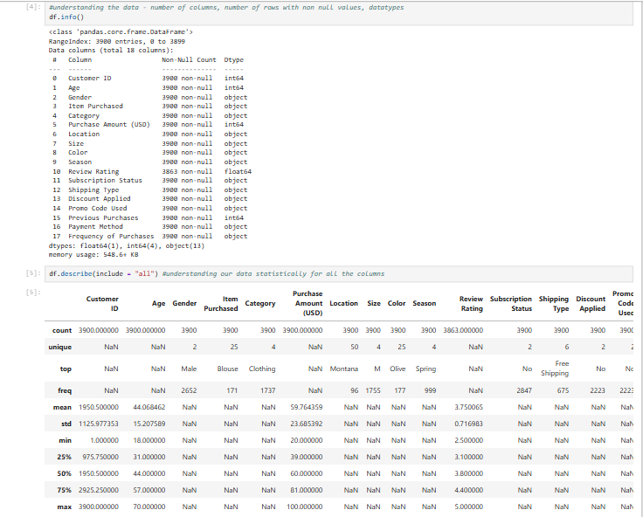
- Missing Data Handling: Checked for null values and imputed missing values in the Review Rating column using the median rating of each product category.
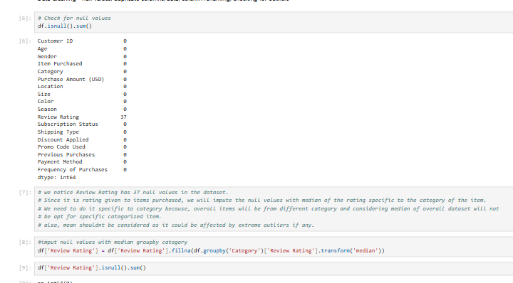
- Column Standardization: Renamed columns to proper case for better readability and documentation.
- Feature Engineering: Created age_group column by binning customer ages.
- Data Consistency Check: Verified if discount_applied and promo_code_used were redundant; dropped promo_code_used.
- Database Integration: Connected Python script to SQLServer and loaded the cleaned DataFrame into the database for SQL analysis

4. Data Analysis using SQL (Business Transactions)
1. Revenue by Gender – Compared total revenue generated by male vs. female customers
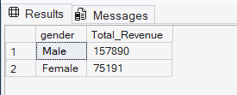
2. Top 5 Products with highest Average Rating
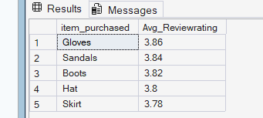
3. Shipping Type Comparison – Compared average purchase amounts between Standard and Express shipping.
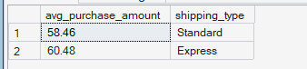

4. Subscribers vs. Non-Subscribers – Compared average spend and total revenue across subscription status.
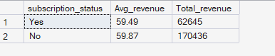

5. Discount-Dependent Products – Identified 5 products with the highest percentage of discounted purchases
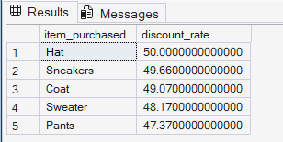

6. Customer Segmentation – Classified customers into new, returning, and loyal segments based on purchase history.
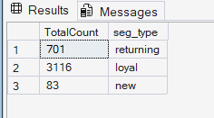

7. Top 3 Products per Category – Listed the most purchased products within each category.
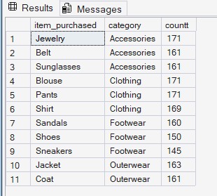

8. Repeat Buyers & Subscriptions – Checked whether customers with >5 purchases are more likely to subscribe.
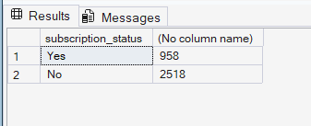
9. Revenue by Age Group – Calculated total revenue contribution of each age group
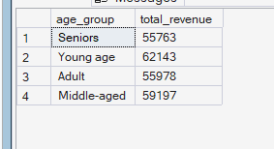

5. Dashboard in Power BI: Built an interactive dashboard in Power BI to present insights visually
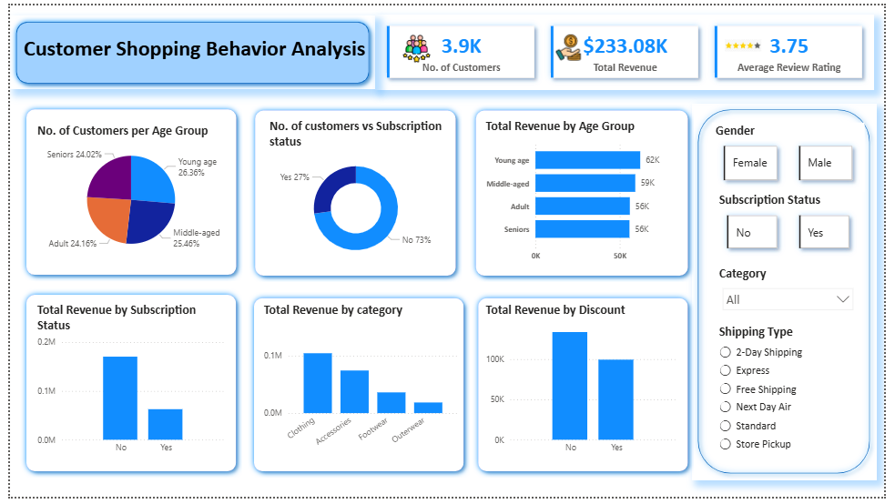
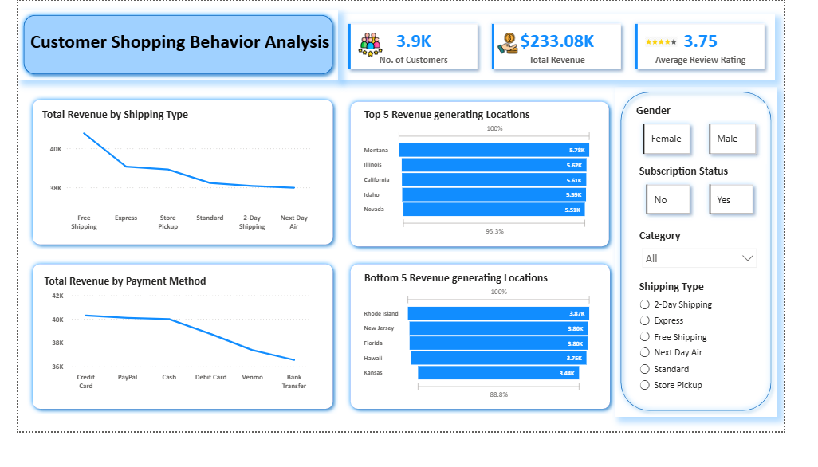
Key Insights & Business Conclusions
- Non-subscribed customers generate ~73% of total revenue, while average spend is nearly identical across subscription types.
- Clothing and Accessories are the highest revenue-generating product categories, with Free and Express Shipping driving most sales.
- Discounts do not significantly increase spending, indicating limited effectiveness of current promotional strategies.
- Average customer rating of 3.75 suggests moderate satisfaction with opportunities to improve customer experience.
- Geographic sales concentration highlights potential for targeted regional marketing and optimized subscription incentives.

